NAME_________________________________________________ PHONE________________________
(PRINT NAME CLEARLY & EXACTLY AS YOU WANT IT TO APPEAR ON THE JACKET)

ADDRESS_____________________________________________________________________________
(SHIPPING ADDRESS: DELIVERED DIRECTLY TO YOUR HOME VIA UPS NO P.O. BOX)

CITY____________________________________________ STATE_______________ ZIP_____________

EVENTS _____________________________________________________________________________

____________________________________________________________________________________
PRINT CONTESTANT’S EVENTS CLEARLY. EVENTS WILL APPEAR EXACTLY AS WRITTEN ON FRONT OF JACKET. (I.E. DO YOU WANT BARRELS OR BARREL RACING, BREAKAWAY OR BREAKAWAY ROPING, TIE DOWN OR TIE DOWN CALF ROPING)
AVALIABLE SIZES LISTED BELOW:
_____YTH MEDIUM _____ADULT X-SMALL _____ADULT LARGE
_____YTH LARGE _____ADULT SMALL _____ADULT X-LARGE
_____YTH XL _____ADULT MEDIUM
JACKET COST $190 YOUTH SIZES - $200 ADULT SIZES or $210 FOR XXL-4XL SIZES
THIS GJHSRA JACKET IS MADE FOR US BY CARROLL ORIGINAL WEAR. THE “MAVERICK” STYLE JACKET IS ITEM #COW579BK AND CAN BE VIEWED AT THEIR WEBSITE. THE JACKET IS BLACK WOOL WITH BLACK LEATHER SLEEVES AND COLLAR. IT WILL FEATURE THE JR HIGH LOGO ON THE BACK WITH CONTESTANTS NAME WILL BE LISTED ON LEFT FRONT AND EVENTS LISTED ON RIGHT FRONT.
THESE JACKETS TAKE 6-8 WEEKS FOR DELIVERY. I WILL BE PLACING THE FIRST ORDER RIGHT AFTER THE MADISON RODEO SO THAT THEY WILL BE SHIPPED TO YOU IN TIME FOR CHRISTMAS. PLEASE FILL OUT THE FORM AND BRING IT, ALONG WITH PAYMENT, TO MADISON IF YOU WOULD LIKE A JACKET. YOU CAN ALSO MAIL THE FORM AND PAYMENT TO SHANNON BUCHANAN, 1285 LL REVELL ROAD MANCHESTER, GA 31816
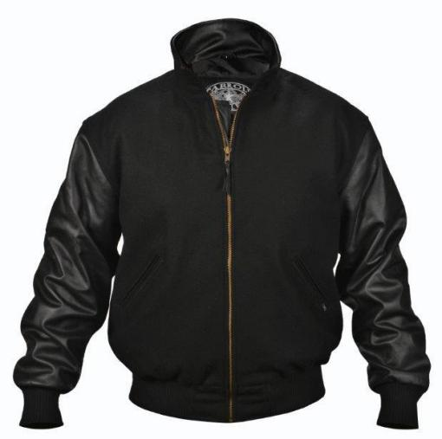
JACKET AMOUNT: $_________
ADDITIONAL SHIELDS $_________
ADDITIONAL CHEVRONS: $_________
SHIPPING: $__20_____
TOTAL AMOUNT DUE: $_________

SHIELDS ($12 each) CAN BE ADDED TO THE JACKET ARM EACH YEAR FOR BACK NUMBERS
CHEVRONS ($9 each) ON ARM CAN BE USED TO HIGHLIGHT THINGS LIKE CHAMPIONS OR NATIONAL QUALIFIERS ETC.

